Dal to my Pie – Slow Cooker
Inspired by



DID YOU KNOW?
“COOL FACT HERE ABOUT BABY POTATOES!”

Nutrition – Total / Per Serving
Calories: ?kcal / ?kcal
Carbohydrates: ?g / ?g
Protein: ?g / ?g
Fat: ?g / ?g
Fibre: ?g / ?g
Sugar: ?g / ?g
Ingredients
350g of baby potatoes
1 onion
1 carrot
4 garlic cloves
1 tin of green lentils
250g of halloumi (or paneer)
1 tbsp tomato puree
1 tin of light coconut milk
1 vegetable stock
100ml of water
3 tsp Baharat seasoning






Good for:

Star Rating:




Method
Step 1 - Preparation
Preheat your slow cooker.
Dice the onion and garlic.
Cut your potatoes and carrot into bite size chunks.
Drain and rinse the lentils.
Dice the halloumi and place in a bowl for later (once the meal has been in the slow cooker).

SLOW COOKER

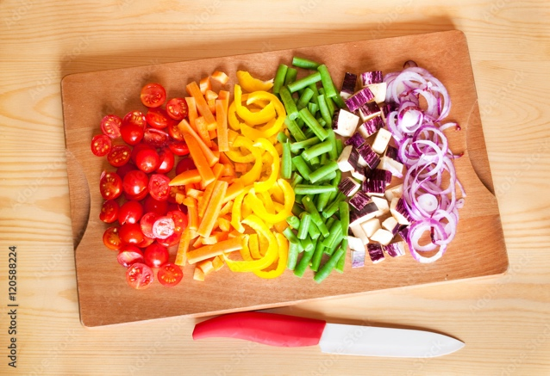
Step 2 – Pop It In and Away You Go!
Once your slow cooker is ready and you have prepped your ingredients, place them all in the slow cooker.
Season with salt & pepper.
Stir well, pop the lid back on and leave it for ~3 hours (if on a high setting) or ~5 hours (if on a low setting).
If you are in the house, be sure to check on it and give a stir when you get a moment.
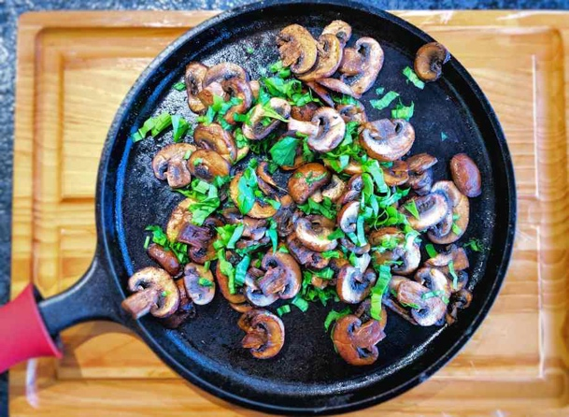
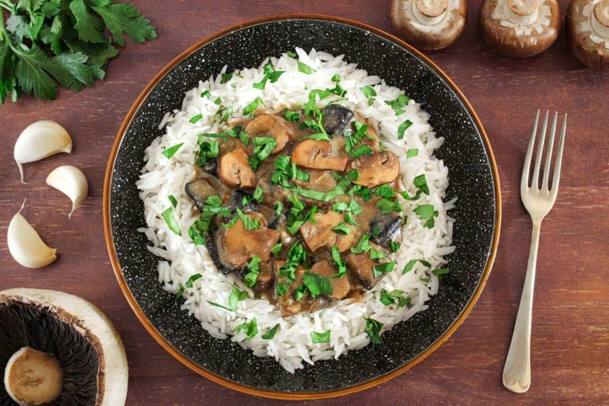
Step 3 – Fry it up!
Heat some oil in the frying pan.
Once the pan and oil are hot, place the halloumi in it. Season with salt & pepper.
Fry until golden on all sides, ensure to keep turning the halloumi to prevent them from burning. (~5 mins).
Step 4 – Serve, Easy as Pie!
Turn the heat off for the frying pan.
Give your dal one more stir before serving into bowls.
Place the halloumi on top and serve.

Enjoy!

